DAY-11
1.Write a C program to search for a number, Min, Max from a BST
#include <stdio.h>
#include <stdlib.h>
typedef struct Node {
int data;
struct Node* left;
struct Node* right;
} Node;
Node* createNode(int data) {
Node* newNode = (Node*)malloc(sizeof(Node));
newNode->data = data;
newNode->left = NULL;
newNode->right = NULL;
return newNode;
}
Node* insertNode(Node* root, int data) {
if (root == NULL) {
return createNode(data);
}
if (data < root->data) {
root->left = insertNode(root->left, data);
} else if (data > root->data) {
root->right = insertNode(root->right, data);
}
return root;
}
void inorderTraversal(Node* root) {
if (root == NULL) {
return;
}
inorderTraversal(root->left);
printf("%d ", root->data);
inorderTraversal(root->right);
}
int searchNode(Node* root, int key) {
if (root == NULL) {
return 0;
}
if (key == root->data) {
return 1;
}
if (key < root->data) {
return searchNode(root->left, key);
} else {
return searchNode(root->right, key);
}
}
int findMin(Node* root) {
if (root == NULL) {
return -1;
}
while (root->left != NULL) {
root = root->left;
}
return root->data;
}
int findMax(Node* root) {
if (root == NULL) {
return -1;
}
while (root->right != NULL) {
root = root->right;
}
return root->data;
}
int main() {
Node* root = NULL;
root = insertNode(root, 50);
root = insertNode(root, 30);
root = insertNode(root, 20);
root = insertNode(root, 40);
root = insertNode(root, 70);
root = insertNode(root, 60);
root = insertNode(root, 80);
printf("Inorder Traversal: ");
inorderTraversal(root);
printf("\n");
int key = 40;
if (searchNode(root, key)) {
printf("Found %d in the BST.\n", key);
} else {
printf("%d not found in the BST.\n", key);
}
int min = findMin(root);
printf("Minimum value in the BST: %d\n", min);
int max = findMax(root);
printf("Maximum value in the BST: %d\n", max);
return 0;
}
OUTPUT:
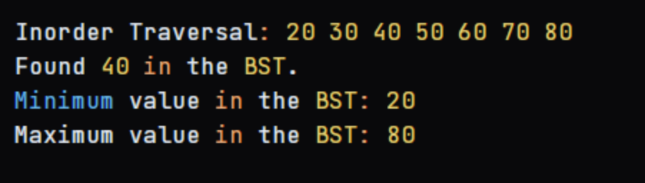
2.Write a C program to perform the following operations:
a) Insert an element into a AVL tree.
b) Delete an element from a AVL tree.
c) Search for a key element in a AVL tree.
#include <stdio.h>
#include <stdlib.h>
struct Node {
int key;
struct Node* left;
struct Node* right;
int height;
};
int height(struct Node* N) {
if (N == NULL)
return 0;
return N->height;
}
int max(int a, int b) {
return (a > b) ? a : b;
}
struct Node* newNode(int key) {
struct Node* node = (struct Node*)malloc(sizeof(struct Node));
node->key = key;
node->left = NULL;
node->right = NULL;
node->height = 1;
return node;
}
struct Node* rightRotate(struct Node* y) {
struct Node* x = y->left;
struct Node* T2 = x->right;
x->right = y;
y->left = T2;
y->height = max(height(y->left), height(y->right)) + 1;
x->height = max(height(x->left), height(x->right)) + 1;
return x;
}
struct Node* leftRotate(struct Node* x) {
struct Node* y = x->right;
struct Node* T2 = y->left;
y->left = x;
x->right = T2;
x->height = max(height(x->left), height(x->right)) + 1;
y->height = max(height(y->left), height(y->right)) + 1;
return y;
}
int getBalance(struct Node* N) {
if (N == NULL)
return 0;
return height(N->left) - height(N->right);
}
struct Node* insert(struct Node* node, int key) {
if (node == NULL)
return (newNode(key));
if (key < node->key)
node->left = insert(node->left, key);
else if (key > node->key)
node->right = insert(node->right, key);
else
return node;
node->height = 1 + max(height(node->left), height(node->right)));
int balance = getBalance(node);
if (balance > 1 && key < node->left->key)
return rightRotate(node);
if (balance < -1 && key > node->right->key)
return leftRotate(node);
if (balance > 1 && key > node->left->key) {
node->left = leftRotate(node->left);
return rightRotate(node);
}
if (balance < -1 && key < node->right->key) {
node->right = rightRotate(node->right);
return leftRotate(node);
}
return node;
}
struct Node* minValueNode(struct Node* node) {
struct Node* current = node;
while (current->left != NULL)
current = current->left;
return current;
}
struct Node* deleteNode(struct Node* root, int key) {
if (root == NULL)
return root;
if (key < root->key)
root->left = deleteNode(root->left, key);
else if (key > root->key)
root->right = deleteNode(root->right, key);
else {
if ((root->left == NULL) || (root->right == NULL)) {
struct Node* temp = root->left ? root->left : root->right;
if (temp == NULL) {
temp = root;
root = NULL;
} else
*root = *temp;
free(temp);
} else {
struct Node* temp = minValueNode(root->right);
root->key = temp->key;
root->right = deleteNode(root->right, temp->key);
}
}
if (root == NULL)
return root;
root->height = 1 + max(height(root->left), height(root->right));
int balance = getBalance(root);
if (balance > 1 && getBalance(root->left) >= 0)
return rightRotate(root);
if (balance > 1 && getBalance(root->left) < 0) {
root->left = leftRotate(root->left);
return rightRotate(root);
}
if (balance < -1 && getBalance(root->right) <= 0)
return leftRotate(root);
if (balance < -1 && getBalance(root->right) > 0) {
root->right = rightRotate(root->right);
return leftRotate(root);
}
return root;
}
struct Node* search(struct Node* root, int key) {
if (root == NULL || root->key == key)
return root;
if (root->key < key)
return search(root->right, key);
return search(root->left, key);
}
void inOrder(struct Node* root) {
if (root != NULL) {
inOrder(root->left);
printf("%d ", root->key);
inOrder(root->right);
}
}
int main() {
struct Node* root = NULL;
root = insert(root, 10);
root = insert(root, 20);
root = insert(root, 30);
root = insert(root, 40);
root = insert(root, 50);
root = insert(root, 25);
printf("In-order traversal of the AVL tree is: ");
inOrder(root);
printf("\n");
int key = 30;
struct Node* foundNode = search(root, key);
if (foundNode != NULL)
printf("Element %d found in the AVL tree.\n", key);
else
printf("Element %d not found in the AVL tree.\n", key);
printf("Deleting element 30 from the AVL tree.\n");
root = deleteNode(root, 30);
printf("In-order traversal after deletion: ");
inOrder(root);
printf("\n");
return 0;
}
OUTPUT:
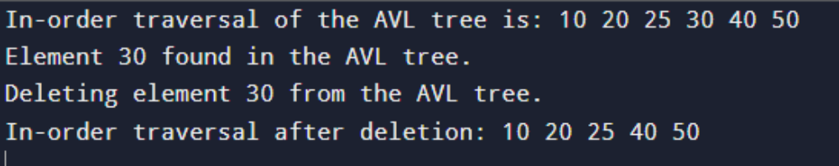
3. implement Red black tree.
#include <stdio.h>
#include <stdlib.h>
typedef enum { RED, BLACK } Color;
typedef struct Node {
int data;
struct Node* left;
struct Node* right;
struct Node* parent;
Color color;
} Node;
Node* createNode(int data) {
Node* newNode = (Node*)malloc(sizeof(Node));
newNode->data = data;
newNode->left = NULL;
newNode->right = NULL;
newNode->parent = NULL;
newNode->color = RED;
return newNode;
}
void leftRotate(Node** root, Node* x) {
Node* y = x->right;
x->right = y->left;
if (y->left != NULL) {
y->left->parent = x;
}
y->parent = x->parent;
if (x->parent == NULL) {
*root = y;
} else if (x == x->parent->left) {
x->parent->left = y;
} else {
x->parent->right = y;
}
y->left = x;
x->parent = y;
}
void rightRotate(Node** root, Node* x) {
Node* y = x->left;
x->left = y->right;
if (y->right != NULL) {
y->right->parent = x;
}
y->parent = x->parent;
if (x->parent == NULL) {
*root = y;
} else if (x == x->parent->right) {
x->parent->right = y;
} else {
x->parent->left = y;
}
y->right = x;
x->parent = y;
}
void fixInsert(Node** root, Node* k) {
while (k->parent->color == RED) {
if (k->parent == k->parent->parent->left) {
Node* u = k->parent->parent->right;
if (u->color == RED) {
u->color = BLACK;
k->parent->color = BLACK;
k->parent->parent->color = RED;
k = k->parent->parent;
} else {
if (k == k->parent->right) {
k = k->parent;
leftRotate(root, k);
}
k->parent->color = BLACK;
k->parent->parent->color = RED;
rightRotate(root, k->parent->parent);
}
} else {
Node* u = k->parent->parent->left;
if (u->color == RED) {
u->color = BLACK;
k->parent->color = BLACK;
k->parent->parent->color = RED;
k = k->parent->parent;
} else {
if (k == k->parent->left) {
k = k->parent;
rightRotate(root, k);
}
k->parent->color = BLACK;
k->parent->parent->color = RED;
leftRotate(root, k->parent->parent);
}
}
}
(*root)->color = BLACK;
}
void insertNode(Node** root, int data) {
Node* k = createNode(data);
Node* y = NULL;
Node* x = *root;
while (x != NULL) {
y = x;
if (k->data < x->data) {
x = x->left;
} else {
x = x->right;
}
}
k->parent = y;
if (y == NULL) {
*root = k;
} else if (k->data < y->data) {
y->left = k;
} else {
y->right = k;
}
fixInsert(root, k);
}
void printTree(Node* root, int indent) {
if (root != NULL) {
printTree(root->right, indent + 4);
for (int i = 0; i < indent; i++) {
printf(" ");
}
printf("%d (%s)\n", root->data, root->color == RED ? "RED" : "BLACK");
printTree(root->left, indent + 4);
}
}
int main() {
Node* root = NULL;
insertNode(&root, 10);
insertNode(&root, 20);
insertNode(&root, 5);
insertNode(&root, 3);
insertNode(&root, 7);
insertNode(&root, 15);
insertNode(&root, 25);
printf("Red-Black Tree:\n");
printTree(root, 0);
return 0;
}
OUTPUT:
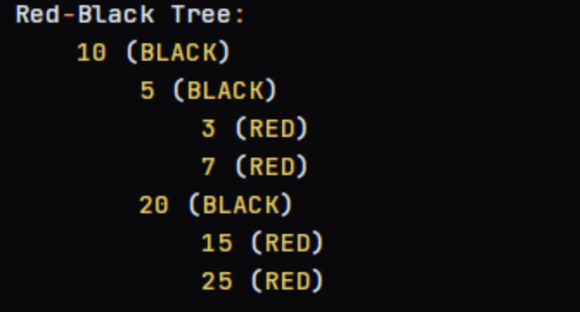
4. implement B Tree.
#include <stdio.h>
#include <stdlib.h>
#define T 3
typedef struct Node {
int *keys;
struct Node **children;
int n;
int leaf;
} Node;
Node* createNode(int leaf) {
Node* newNode = (Node*)malloc(sizeof(Node));
newNode->keys = (int*)malloc((2*T-1)*sizeof(int));
newNode->children = (Node**)malloc((2*T)*sizeof(Node*));
newNode->n = 0;
newNode->leaf = leaf;
return newNode;
}
void insert(Node** root, int k) {
Node* r = *root;
if (r == NULL) {
*root = createNode(1);
(*root)->keys[0] = k;
(*root)->n = 1;
} else {
if (r->leaf) {
int i = r->n - 1;
while (i >= 0 && k < r->keys[i]) {
r->keys[i+1] = r->keys[i];
i--;
}
r->keys[i+1] = k;
r->n++;
if (r->n == 2*T-1) {
Node* newNode = createNode(0);
(*root) = newNode;
newNode->children[0] = r;
splitChild(newNode, 0, r);
insertNonFull(newNode, k);
}
} else {
int i = r->n - 1;
while (i >= 0 && k < r->keys[i]) {
i--;
}
i++;
if (r->children[i]->n == 2*T-1) {
splitChild(r, i, r->children[i]);
if (k > r->keys[i]) {
i++;
}
}
insertNonFull(r->children[i], k);
}
}
}
void splitChild(Node* x, int i, Node* y) {
Node* z = createNode(y->leaf);
x->children[i+1] = z;
x->keys[i] = y->keys[T-1];
z->n = T-1;
for (int j = 0; j < T-1; j++) {
z->keys[j] = y->keys[j+T];
}
if (!y->leaf) {
for (int j = 0; j < T; j++) {
z->children[j] = y->children[j+T];
}
}
y->n = T-1;
x->n++;
}
void insertNonFull(Node* x, int k) {
int i = x->n - 1;
if (x->leaf) {
while (i >= 0 && k < x->keys[i]) {
x->keys[i+1] = x->keys[i];
i--;
}
x->keys[i+1] = k;
x->n++;
} else {
while (i >= 0 && k < x->keys[i]) {
i--;
}
i++;
if (x->children[i]->n == 2*T-1) {
splitChild(x, i, x->children[i]);
if (k > x->keys[i]) {
i++;
}
}
insertNonFull(x->children[i], k);
}
}
void printTree(Node* x, int indent) {
if (x != NULL) {
for (int i = x->n - 1; i >= 0; i--) {
printTree(x->children[i+1], indent + 4);
for (int j = 0; j < indent; j++) {
printf(" ");
}
printf("%d\n", x->keys[i]);
}
printTree(x->children[0], indent + 4);
}
}
int main() {
Node* root = NULL;
insert(&root, 10);
insert(&root, 20);
insert(&root, 5);
insert(&root, 3);
insert(&root, 7);
insert(&root, 15);
insert(&root, 25);
printf("B-Tree:\n");
printTree(root, 0);
return 0;
}
OUTPUT:
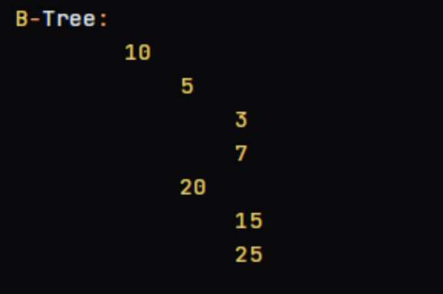
5. implement B+ Tree.
#include <stdio.h>
#include <stdlib.h>
#define MAX 3
typedef struct BPlusNode {
int keys[MAX - 1];
struct BPlusNode *children[MAX];
struct BPlusNode *next;
int numKeys;
int isLeaf;
} BPlusNode;
BPlusNode *root = NULL;
BPlusNode* createNode(int isLeaf) {
BPlusNode *newNode = (BPlusNode*)malloc(sizeof(BPlusNode));
newNode->isLeaf = isLeaf;
newNode->numKeys = 0;
newNode->next = NULL;
for (int i = 0; i < MAX; i++) {
newNode->children[i] = NULL;
}
return newNode;
}
void splitChild(BPlusNode *parent, int index, BPlusNode *fullNode) {
BPlusNode *newNode = createNode(fullNode->isLeaf);
newNode->numKeys = (MAX - 1) / 2;
for (int j = 0; j < newNode->numKeys; j++) {
newNode->keys[j] = fullNode->keys[j + (MAX + 1) / 2];
}
if (!fullNode->isLeaf) {
for (int j = 0; j <= newNode->numKeys; j++) {
newNode->children[j] = fullNode->children[j + (MAX + 1) / 2];
}
}
fullNode->numKeys = (MAX - 1) / 2;
for (int j = parent->numKeys; j >= index + 1; j--) {
parent->children[j + 1] = parent->children[j];
}
parent->children[index + 1] = newNode;

for (int j = parent->numKeys - 1; j >= index; j--) {
parent->keys[j + 1] = parent->keys[j];
}
parent->keys[index] = fullNode->keys[(MAX - 1) / 2];
parent->numKeys++;
}
void insert(int key) {
if (root == NULL) {
root = createNode(1);
}
BPlusNode *current = root;
while (!current->isLeaf) {
int i = 0;
while (i < current->numKeys && key > current->keys[i]) {
i++;
}
current = current->children[i];
}
int i = current->numKeys - 1;
while (i >= 0 && key < current->keys[i]) {
current->keys[i + 1] = current->keys[i];
i--;
}
current->keys[i + 1] = key;
current->numKeys++;
if (current->numKeys == MAX) {
BPlusNode *parent = root;
if (parent->numKeys == MAX) {
BPlusNode *newRoot = createNode(0);
newRoot->children[0] = parent;
splitChild(newRoot, 0, parent);
root = newRoot;
} else {
splitChild(parent, parent->numKeys, current);
}
}
}
BPlusNode* search(int key) {
BPlusNode *current = root;
while (current != NULL) {
int i = 0;
while (i < current->numKeys && key > current->keys[i]) {
i++;
}
if (i < current->numKeys && key == current->keys[i]) {
return current;
}
if (current->isLeaf) {
break;
}
current = current->children[i];
}
return NULL;
}
void printTree(BPlusNode *node) {
if (node != NULL) {
for (int i = 0; i < node->numKeys; i++) {
printf("%d ", node->keys[i]);
}
printf("\n");

if (!node->isLeaf) {
for (int i = 0; i <= node->numKeys; i++) {
printTree(node->children[i]);
}
}
}
}
int main() {
insert(5);
insert(10);
insert(15);
insert(20);
insert(25);
insert(30);
insert(35);
insert(40);
insert(45);
insert(50);
printf("B+ Tree structure:\n");
printTree(root);
int key = 25;
BPlusNode *result = search(key);
if (result != NULL) {
printf("Key %d found in the B+ Tree.\n", key);
} else {
printf("Key %d not found in the B+ Tree.\n", key);
}
return 0;
}
OUTPUT:
